South Gloucestershire Council
Title: Street Lighting: the sustainable LED replacement programme

Category 1: Delivering Clean Growth

One sentence summary (no more than 150 characters).
The sustainable benefits of adopting a 10 year programme to replace street lighting with LEDs have reduced capital spend, CO2 consumption and saved £2.5m cumulative energy.
(147 characters)

500 words outlining the project

In 2014 South Gloucestershire Council embarked on a programme to replace street lighting lanterns with Light Emitting Diode (LED). Unlike other councils South Gloucestershire opted for a 10 year sustainable replacement programme. Now halfway through, the programme has exceeded expectations by taking advantage of evolving technology to reduce annual capital spend by over £700k. Alongside this the increased energy efficiency of LED lanterns has reduced CO2 consumption and saved £2.5m cumulative energy.

In recent years funding from central government has reduced while demand to deliver improved services has increased. In response to these pressures, along with rising energy costs, advances in technology and ambitions to provide more efficient and sustainable services South Gloucestershire Council reviewed its street lighting service.

The introduction of LED lanterns to replace the existing lanterns was widely recognised as a major energy saving initiative. The challenge for the council was whether to replace the 30,000+ existing lanterns in one sweeping initiative or to take a longer term, more sustainable approach.

Street lighting accounts for 25% of the council’s energy spend. Replacing the lanterns in a short term ‘quick win’ initiative was estimated at £14 million with immediate energy savings. The alternative was to take a longer term ‘invest to save’ approach over a 10 year period. This approach would require reduced initial outlay, help manage waste and drip feed savings of £1 million per year, which would gradually increase over the life of the programme as more LED lanterns were installed.

An evaluation model was used to comprehensively assess both strategies. Conclusions showed a project of 5 years or less would offer the greatest short term financial savings. However, it clearly demonstrated that going beyond the 3-5 year budget cycle offered a more realistic, cost efficient way to manage resources and assets. In particular negative impacts to staff of adopting the short term programme.

Challenges included breaking down the culture of short term thinking and managing stakeholder expectations. This has been achieved through regularly sharing information internally and stakeholder engagement. Face to face communication with the parish councils prior to installations in their areas is an example of this.

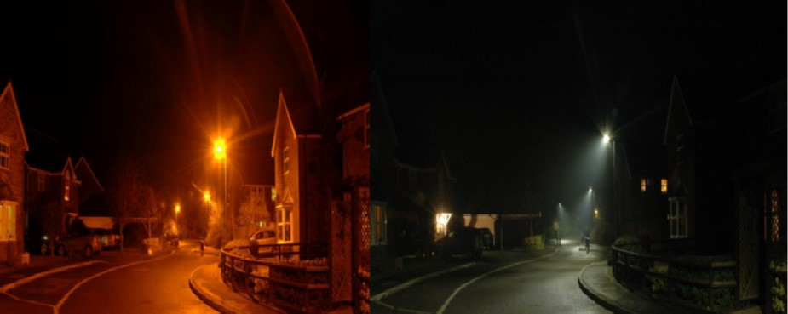

Benefits of the 10 year programme
- The ability to forecast future savings in budget planning.
- Staff redundancies have been avoided as a result of successfully managing the supply chain and utilising available resource.
- The lifetime of existing assets was maximised and unnecessary waste avoided.
- The maintenance team have stripped and re-used over 5,000 items, additionally saving over £500k in material costs.
- New supply chain components are managed through a procurement framework providing suppliers with notice of requirements. The framework provides flexibility to change products and take advantage of advances in technology. This has generated annual capital savings of £700k (2014: £466 per lantern, 2018: £233 per lantern).

To date South Gloucestershire is not aware of any other councils adopting the same strategy. Now five years on, the longer term programme is clearly demonstrating how it is possible to deliver clean growth in a sustainable way.

498 words

