|  |  |
| --- | --- |
| ADEPT President’s Awards 2019 | |
| Category 2: Deploying digital innovation and technology | |
| A picture containing clipart  Description generated with very high confidence | A picture containing clipart  Description generated with very high confidence |

Digital Asset Management Using Artificial Intelligence-Enabled Computer Vision

Summary

Using smartphone video capture and AI technology to survey and analyse high-frequency road condition data supporting future investment strategies and performance outcomes.

|  |  |
| --- | --- |
| ADEPT President’s Awards 2019 | |
| Category 2: Deploying digital innovation and technology | |
| A picture containing clipart  Description generated with very high confidence | A picture containing clipart  Description generated with very high confidence |

Digital Asset Management Using Artificial Intelligence-Enabled Computer Vision

Since 2004/15, local authorities have undertaken formal machine-based condition surveys on their classified networks and either SCANNER or coarse visual inspection (CVI) on local roads. Local authorities are continuously challenged with making significant revenue savings - so SCANNER and CVI surveys of the entire road network span an increasing number of years. CVI personnel interpret condition differently whilst the multiple-year cycle of formal condition surveys makes it difficult to accurately measure deterioration. This cumulatively inhibits the identification of sections of road that are at the optimum window for preventative maintenance treatments.

Suffolk County Council (SCC) in partnership with Vaisala have self-funded and delivered a project to evaluate the effectiveness of Vaisala’s “Road AI” technology to automatically detect, classify and consistently report road surface defects in line with UKPMS methodology across all road types. The strategic goal is to leverage this to high frequency, on-demand data generation that will drive planning and programming, optimise defect correction works, and enable analysis of the durability and performance of different road maintenance techniques.

Existing processes for evaluating and recording road condition rely on point-in-time surveys using bespoke equipment, or specialist contractors or personnel; using Vaisala’s Road AI system, video survey data is collected using a smartphone. Local authority personnel or vehicles without any specialist training or knowledge can therefore collect data whilst going about their normal business on the network. They can thus provide a continuously updated data set for analysis and production of condition reports, on demand, via an online user interface. The analysed data is delivered in a format that can be ingested into existing accredited asset management systems to enable forward planning using established processes.

This technology enables the authority to have up-to-date live condition data throughout the year, giving scope to monitor the impact of seasonal weather, measure accurate deterioration curves, generate real-time asset performance and creation of forward works programmes. The bank of condition data can also assess the overall performance of road assets across the entire network, enabling life-cycle plans to be honed for different geological locations and construction types, leading to improved long-term investment strategies and performance outcomes. Map-based user interface “heatmap” and exception reports are also generated, highlighting new defects since the previous survey to identify areas where the network is deteriorating.

In addition to the road condition data, the system also captures Traffic Signs Regulations and General Directions 2016-compliant road sign location and diagram numbers – thereby automatically creating exception reports for locations where signage is missing. This can be further tailored to locate missing mandatory/regulatory signs in urgent need of replacement.

The system’s combined multiple asset condition and inventory collection capability embraces an asset management culture, sparking interest from the Department of Transport and other local authorities. encouraged by central government. It utilises existing resources efficiently and provides a mechanism to gather and process useful data in a more cost-effective way. The outputs generated so far are now influencing the formation of future programmes of work and analysing the robustness of existing surface treatments.

# Appendix - System examples

Figure 1 - Heatmap illustrating defects across Suffolk CC network

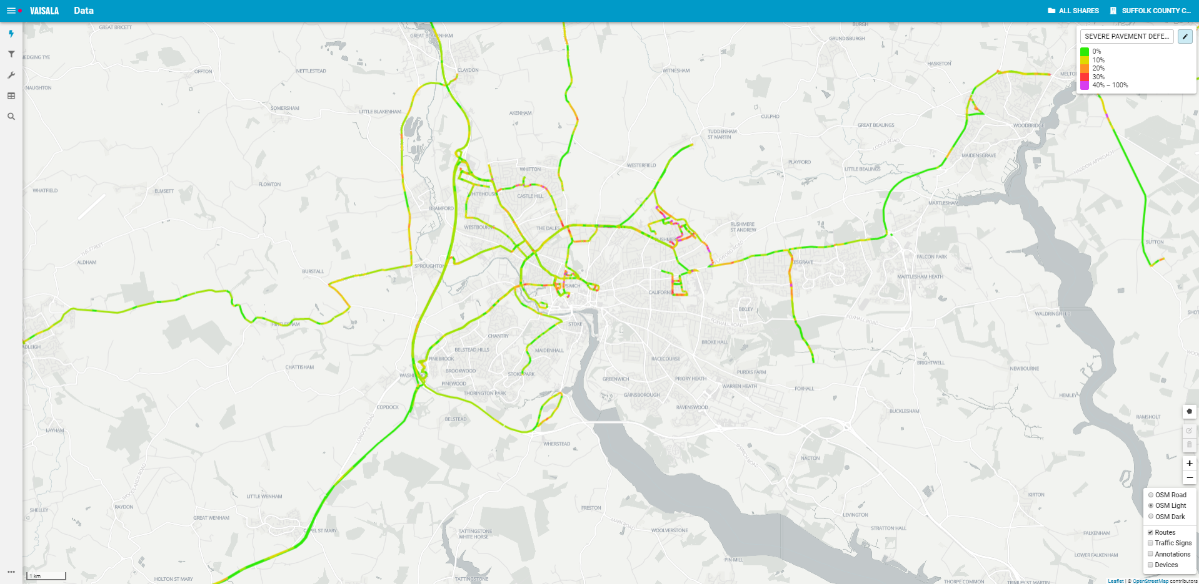

Figure 2 - Segmentation Model enabled illustrating feature classification

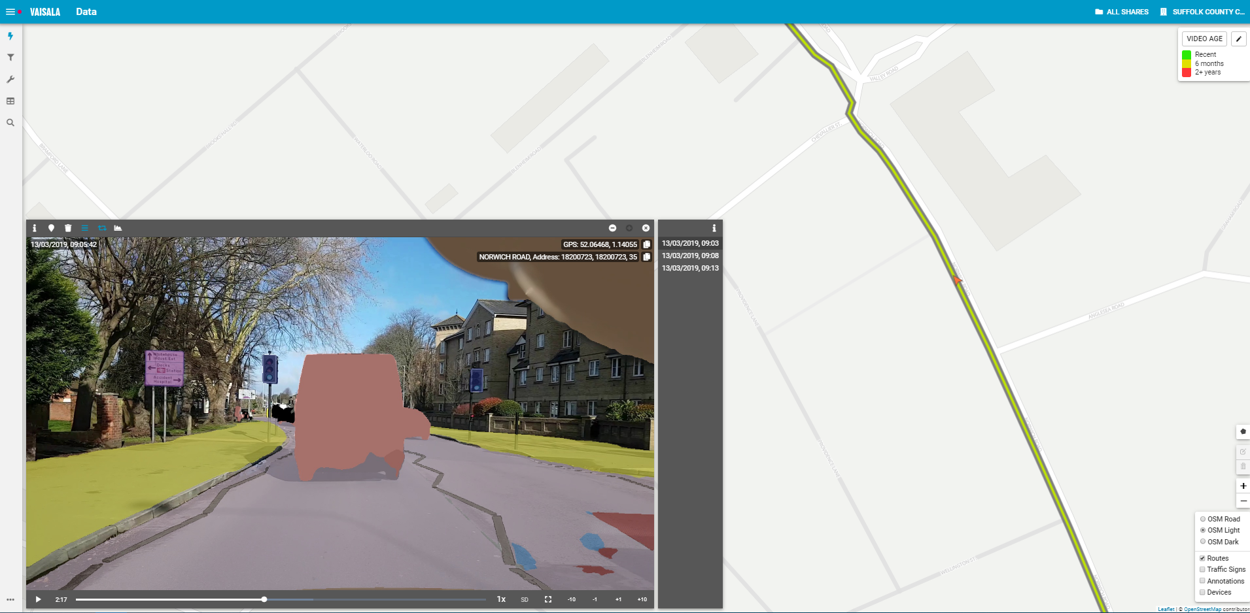

|  |
| --- |
|  |

Figure 3 - Road sign detection and categorisation

# 

Figure 4 - Annotation tool enables efficient capture of any notable defects or other issues affecting the network enabling engineers to raise tasks and track interventions

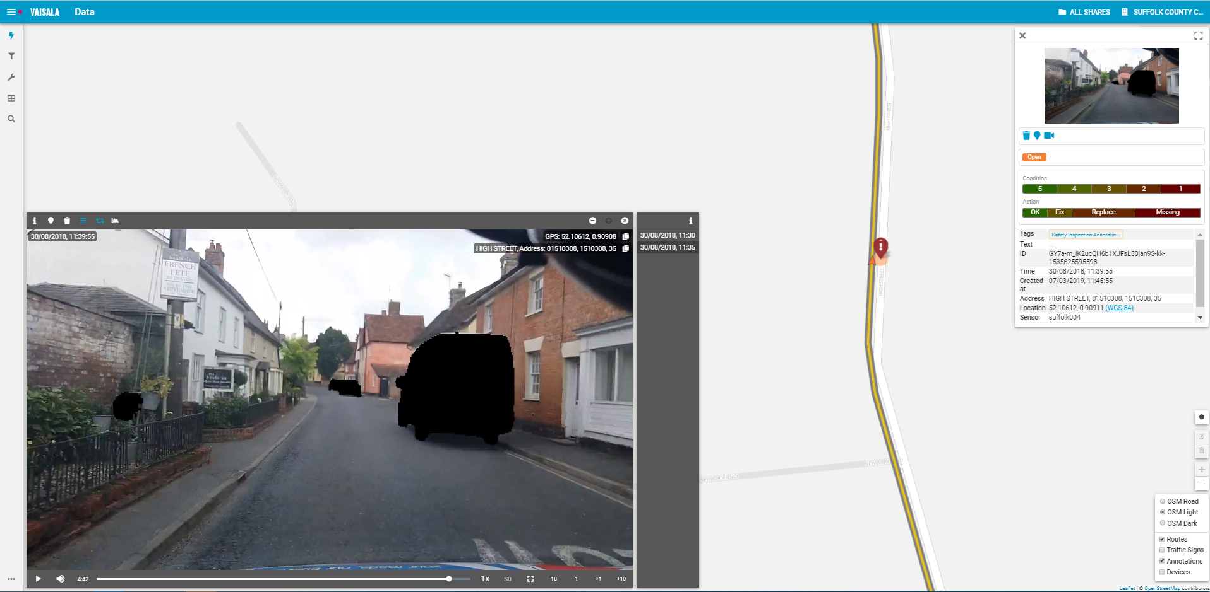

Figure 5 - generation in standard format from User Interface

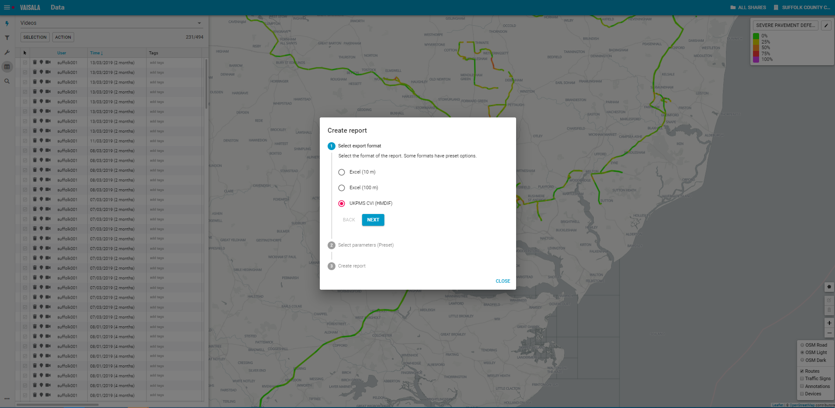

Figure 6 - Road condition data export in HMDIF format

