South Gloucestershire Council
Title: Reducing waste, improving recycling, saving money

Category 3: Improving the environment, promoting health

One sentence summary (no more than 150 characters).
By engaging residents South Gloucestershire council has achieved cost savings, reduced waste and experienced a major shift in recycling behaviour.
(145 Characters)

500 words outlining the project

In 2014/15 the household waste and recycling rate across South Gloucestershire was just 47.5%. Waste generated per household was greater than that in neighbouring authorities. Whilst recognising that improvements were needed the challenge was to find a way to deliver the required changes within a decreasing budget. The council set an objective to achieve cost savings and reach a 50% recycling rate by 2020.

Local and national data was researched and focus groups and surveys were carried out with residents to identify how the ambitious targets might be achieved while still future-proofing the collections service for a growing population. The Waste Management team also considered how the proposed changes would affect large households, residents with medical needs and households with children in nappies before deciding on a dual approach to address the issue.

Before the changes residents had five containers for recycling that were put out on alternating weeks. Working closely with the council’s waste contractor Suez, the council negotiated a change to single-pass vehicles that could provide a weekly service for all recycling containers at the same cost as the previous fortnightly service. This single step helped make the process of recycling easier and simpler for residents by firstly reducing the number of containers from five to three, allowing residents to mix plastic and tins rather than separate them. Secondly the proposal removed the need for residents to remember which recycling box to be put out on any given week, providing an added incentive for residents to recycle more.
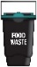
From five recycling containers to three

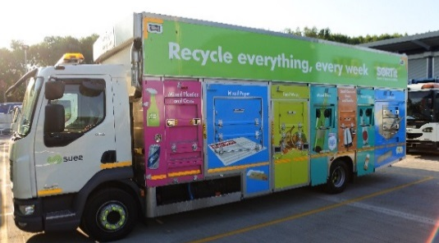
Residents now use fewer containers because of the increased collection frequency. Plastics and cans are accepted mixed in one container to save space. Dry recycling can be presented in two green boxes rather than a mixture of bags and boxes.

The second phase delivered from January 2018 to April 2018 saw a reduction in the previous 240l capacity of bins used for residual household waste. The process of rolling out smaller residual bins began in January when over 111,000 households had their bins exchanged (excluding flats with communal bins) over a 12 week period.

To help the scale of the change go smoothly each bin was delivered with an address sticker attached and an information pack, explaining the change and what to do if households struggled with the new waste capacity.

Residents were kept up to date with the changes through road shows, press releases, social media posts and information packs, explaining the changes and providing information on what to do if households struggled with additional waste.

The Council delivered a strategy that is now demonstrating a reduction in residual waste and an increase in recycled waste. By working in consultation with residents South Gloucestershire Council has experienced a significant shift in recycling behaviour.

National data shows that the target of a 50% recycling rate by 2020 was surpassed in 2017/18 with 51.6%. The latest available data gathered in March 2019 predicts that recycling rates continue their upward trend now reaching an impressive 59%.

494 words

