Summary
East Sussex have deployed an automated quality assurance system to improve road quality, reduce pothole frequency, save money, improve safety and asset management outcomes.
ADEPT President’s Award
East Sussex Highways is a leader amongst local authorities in the adoption and promotion of new technologies to help drive improvement in health and safety, road quality, efficiency, asset management and cost savings.

In partnership with FM Conway, East Sussex Highways consulted with MATtest Southern, the award-winning materials testing innovators, on how to improve the way that asphalt surfacing works are conducted by using new technology.

FM Conway chose to use a MATtest system called Automated Quality Assurance (AQA), designed to replicate and improve on the essential testing that is carried out by materials technicians whenever a new road is built, or an existing road is resurfaced.

Temperature measurements
AQA uses instrumentation placed on construction plant to take continuous temperature measurements of asphalt as it passes through pavers and is rolled by rollers.
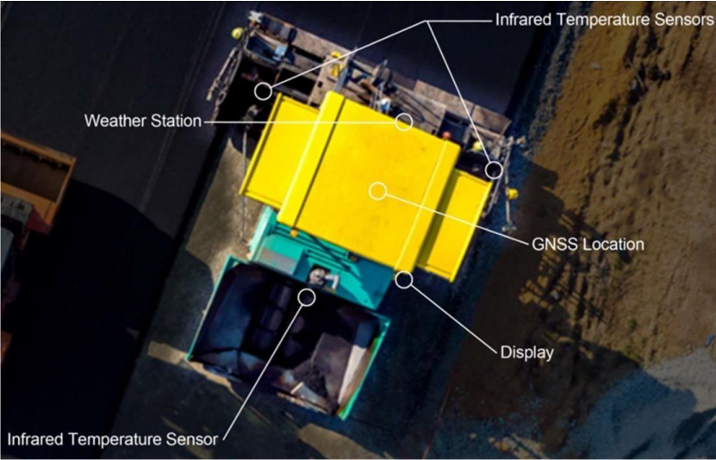

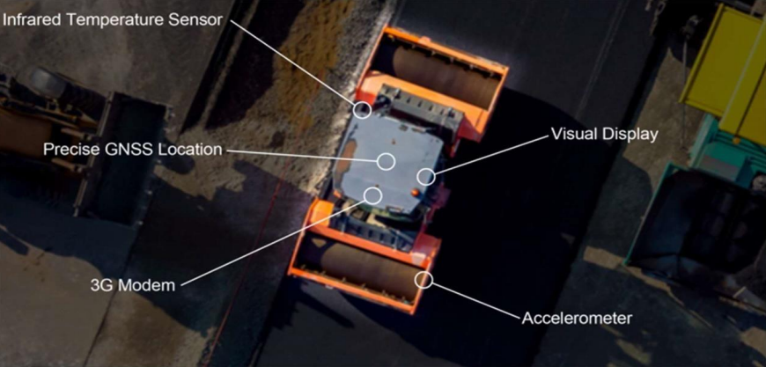

Compaction Monitoring and Preventing Potholes
Maintaining good material delivery and rolling temperatures is a critical part of good road construction, so the real-time information provided by AQA is of great use to site operatives.
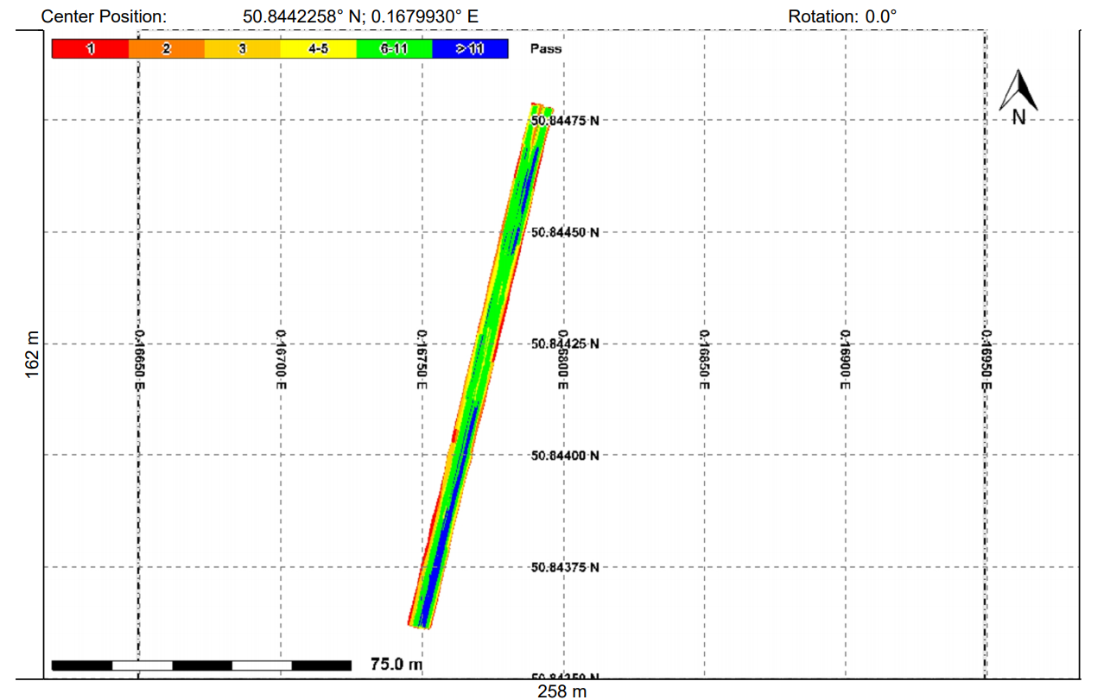
Roller AQA offers much more data – it tests the entirety of the road rather than conventional testing, which covers apprx. 0.07m² per 40m, per wheel track. Roller AQA also enables better use of density data. Instead of testing after compaction, AQA gives real-time data to ensure quality, not just to prove quality.

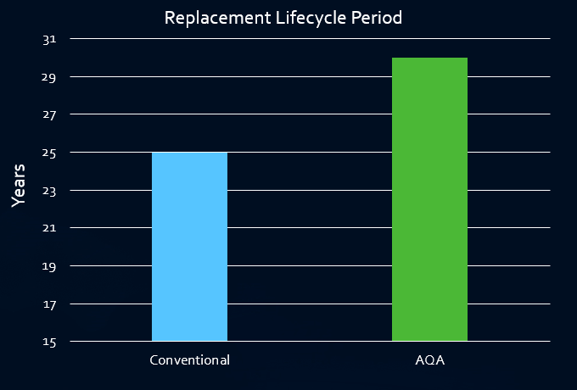
This level of data has been used in other counties (notably Norfolk) to improve roller practices which have led to fewer potholes and longer lifecycles for pavements.

Norfolk County Council Projection, CH2M - Scottish Road Research Board https://www.transport.gov.scot/our-approach/industry-guidance/scottish-road-research-board

Asset Management and the Use of Digital Data
As AQA data is digitally recorded, geo-located, in csv file format, rolling temperatures and other data sets can be uploaded into East Sussex’s asset management system, Map16. By unlocking asset quality data, and identifying potential problem areas, AQA helps asset managers make better pro-active decisions in the maintenance of their assets.

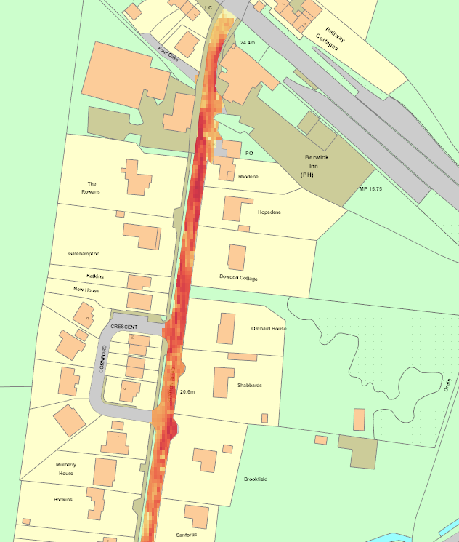
Rolling Temperatures for Station Road, Berwick, East Sussex

Better Ride Quality
Regularity testing normally only shows irregularities. The laser straight edge gives data for the entire road. It can also be used to give International Roughness Index (IRI) figures, a better indication of ride quality. This data is, again, more valuable by being digitally integrable, searchable and comparable.

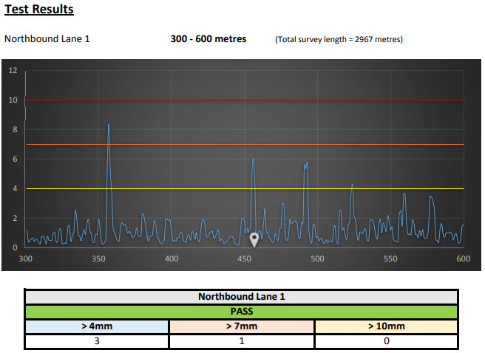
Laser Straight Edge Results Showing Total Road Profile

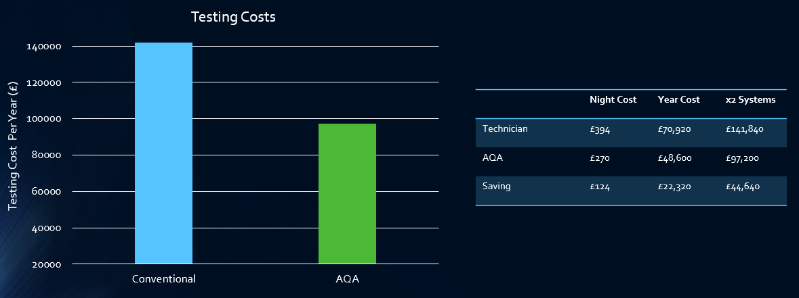
After FM Conway ran a trial with HDS across 3 months in 2018, AQA has now been fully rolled out onto the East Sussex Highways framework and is achieving a 30% reduction in testing costs:

Perhaps the most important thing about the roll out of AQA is the improvement in worker safety that it has led to. AQA improves worker safety by removing technicians from potentially hazardous situations and putting them into the safety of vehicles.

East Sussex and FM Conway are continuing to work closely with MATtest Southern and are looking forward to make use of further innovations in the future.

