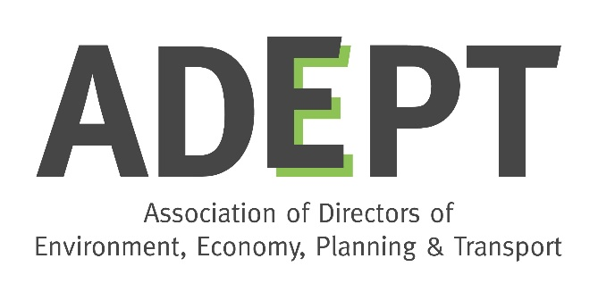
ADEPT Environment Board
Terms of reference
(updated August 2020)

Background

The Association of Directors of Environment, Economy, Planning and Transport (ADEPT) represents Place Directors from county, unitary and metropolitan authorities, along with Local Enterprise Partnerships and corporate partners drawn from key service sectors. ADEPT members are at the very heart of maximising sustainable growth in communities throughout the UK. We are delivering the projects that are key to unlocking broader economic success and creating more resilient communities, economies and infrastructure.

The Environment Board

Remit

The Environment Board leads for ADEPT in understanding and responding to strategic issues and policies relating to the environment. The Board understands that, while sometimes in tension, economic growth and the environment are not necessarily in conflict and can be complementary. In all situations sustainable growth requires good quality environmental planning, investment and infrastructure. We advocate that environmental matters - and tackling and adapting to climate change – must be at the heart of decision making.

The Environment Board has a broad and diverse remit, covering some of the cross-cutting issues which do not sit neatly under the other subject Boards. Its remit includes:
- Waste and material resource management
- Flood & water management
- Energy
- Natural capital & heritage
- Climate change: resilience, adaptation and carbon reduction
- Air quality
- Smart and sustainable approaches to environmental services and planning.

The Board’s agenda is directed by responses to Climate Change, particularly taking into account learnings from the covid-19 epidemic, the Government’s 25 Year Environment Plan (published January 2018) and new environmental legislation associated with EU exit.

Membership

The Board’s membership is voluntary and is drawn from Directors and Heads of Service at member local authorities. It also includes representatives from:
- relevant Government departments – Defra and BEIS
- delivery bodies such as the Environment Agency and Natural England
- London Councils/London Environment Directors’ Network (LEDNet)
- ADEPT corporate partners by invitation for specific issues.

Key personnel and current working groups are as follows:
- Board Chair: Steve Read (West Sussex)
- Deputy Chair: TBC
- Energy Working Group Chair: Carolyn McKenzie (Surrey)
- Flood & Water Working Group: Julia Beeden (Cambridgeshire)
- Waste Working Group: Ian Fielding (North Yorkshire)
- Natural Capital Working Group Co-chairs: Liz Milne (Kent) and Liz Small (North Yorkshire)
- Climate Change Resilience/LAAP: Nigel Riglar (South Gloucestershire).

Meetings and other activities

The Board meets quarterly on-line or in central London. Meetings cover updates from Working Groups, updates from Government departments and agencies on current issues, and invited speakers on specific topics. Meetings are usually followed by an afternoon workshop on a specific theme, often led by one of the Working Groups. Ad hoc meetings may be called, for example as a result of the Covid-19 epidemic the Board met briefly online for updates each month that there was not a main meeting.

The Board holds joint meetings with other ADEPT subject Boards on issues of mutual interest. To date these have been on air quality, with the Transport Board (April 2017), on the National Planning Policy Framework with the Planning, Housing & Regeneration Board (April 2018) and with the Sustainable Growth Board on COP26 (October 2019) and strategic planning for nature conservation (January 2020)

The Board held a joint workshop with an external partner, the Environmental Industries Commission (EIC) in April 2018 on Smart Sustainable Cities, and looks for further opportunities to have similar events.

The Board develops and submits responses to Government consultations on relevant policy matters including air quality, water resources, environmental principles and governance. The Board Chair and Working Group Chairs meet with Ministers and senior officials on an ad hoc basis to discuss current issues.

The Board Chair and Working Group Chairs lead plenary and workshop sessions at the ADEPT annual conference, including natural capital (2016), air quality and energy (2017), and the circular economy (2018). The Chairs also contribute to external conferences and workshops by invitation.

The Board seeks to keep members up to date on current issues, and to share knowledge and best practice between members, by circulating information between meetings.

‘Deep dive’

A report on the Board’s activities, and a stocktake of its strengths and challenges, was submitted to the ADEPT Leadership Team in September 2018 and can be found here.

