PRESIDENT’S ADEPT AWARDS 2019
Category 3: Improving the environment, promoting health - sponsored by WSP

Short summary (149 characters/150)

Innovative Somerset review provides evidence on drainage delivered through the planning process to inform local action and national discussion on maximising SuDS benefits.

Somerset SuDS Review
Daniel Martin, Flood Risk Manager, Somerset County Council
500/500 words.

Introduction

The widely publicised flooding in Somerset in 2012 and 2013/14 led to significant discussion on contributing factors, including the impact of development and how water is managed. Public perception was that development was contributing to flooding downstream and that with climate change this situation would worsen.

The Flood and Water Management Act addressed some areas identified in the Pitt review, but the place of SuDS as a part of the solution to surface water flood risk remains incomplete. Conversations with peers highlight common views on the current shortcomings; quality of designs, achieving multiple benefits, works supervision and long-term maintenance to name a few.

Somerset’s flooding led to an exciting new partnership arrangement, the Somerset Rivers Authority (SRA), and with it a way to raise additional funding. The SRA partners identified a need to review SuDS.

The Somerset SuDS Review was undertaken by Somerset County Council and JBA Consulting to provide unique evidence on the design, construction and maintenance of SuDS through the planning process.

The Review

We began with a high-level review of key trends from over eighty developments from 2003 – 2016. We then focused on twenty sites in detail.

A desk-based study reviewed design and maintenance arrangements, including a high-level assessment of the 'multiple benefits' offered.

Site inspections identified the features and assessed their compliance and current condition. Inspections were supported by colleagues from Wessex Water.
Findings

- Inconsistency in planning documentation and detail of evidence submitted.
- Few sites incorporated source control - most relied on underground or ‘pipe-to-pond’ solutions. Many designs included only one or two SuDS features.

- Climate change had been considered in most designs, but urban creep had not.
- Little evidence of design for directing exceedance flows (image below).

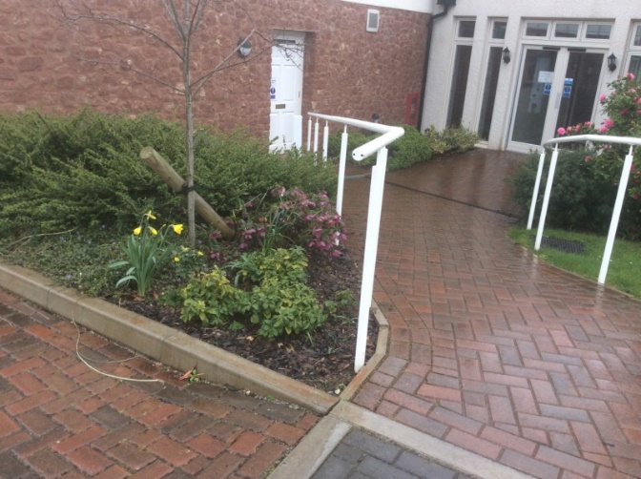

- Little evidence of deliberate provision of water quality, biodiversity and amenity benefits – observed missed opportunities (images below).

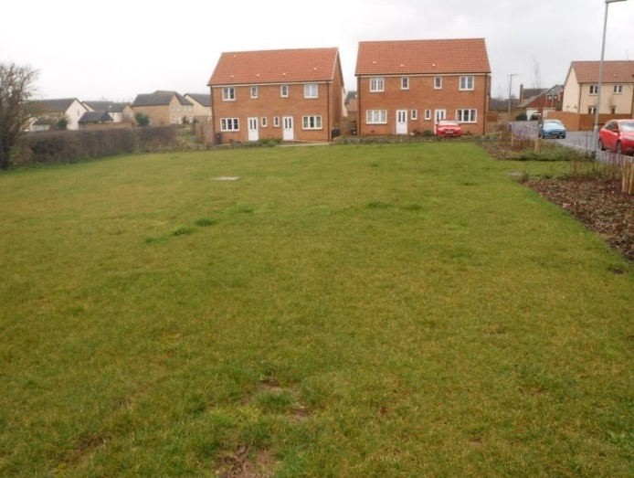 | 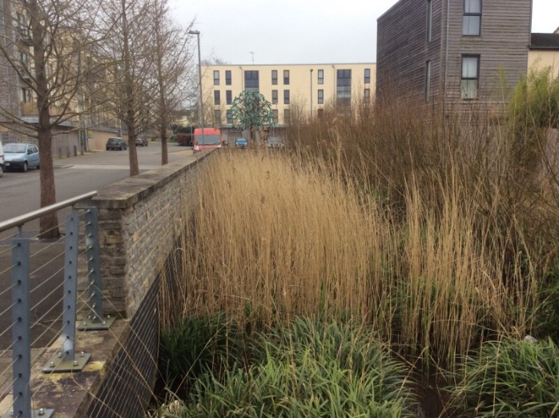

- For schemes under construction we found SuDS damaged by poor site practices and workmanship (images below).

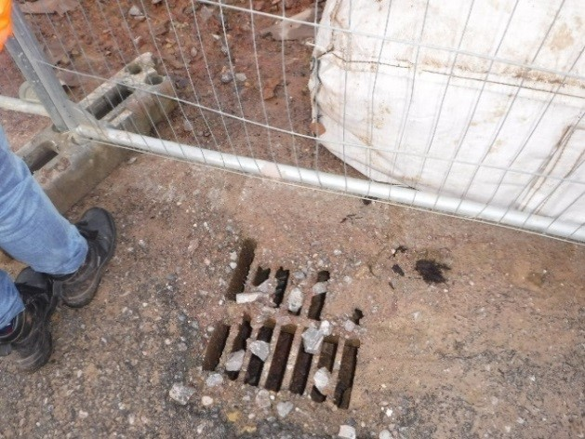 | 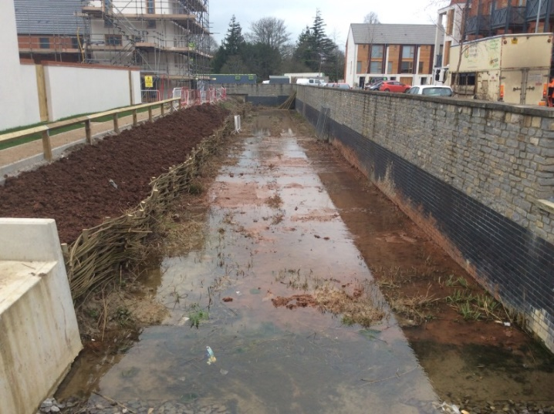

- More positively, we found a high proportion of SuDS being maintained – only 6% were assessed as being in poor condition. This challenged one of the early perceptions.

Outcomes

Through the review authorities in Somerset have identified opportunities to secure better management of surface water in new developments and gather support to champion high-quality SuDS.

Stakeholders in the planning process are collaborating this year to prepare and launch bespoke local guidance for developers. This will communicate our expectations for SuDS to influence their approach to drainage focusing on areas of weakness identified in the review. We are also trialling an innovative SuDS inspection service to ensure designs agreed through planning are implemented on-the-ground.

The review findings will also help us to realise the full potential of SuDS demonstration projects and ensure SuDS are an integral feature in programmes such as the Taunton Garden Town. This valuable evidence is being shared nationally, because these challenges are not confined to Somerset.

With flooding an ever-present risk and with climate change predictions suggesting extreme rainfall events may increase, this work is important in managing our water resources well.

