Improving the environment, promoting health - Influencing a major development for public health benefits – East of Harry Stoke New Neighbourhood
The land south of the railway at East of Harry Stoke is a mixed-use development of up to 1290 homes with community facilities and infrastructure.
The original masterplan put forward by the developer (extract at figure 1) was policy compliant in relation to the quantity of open space and physical activity and included provision for 6 football pitches. It also included a community building located some distance from the open space. Officers felt the outdoor sport offer was limited, appealing mainly to those who enjoy football, and given the potential to deliver a large amount of outdoor sport on-site that the original scheme missed an opportunity to provide for a broader demographic.
A multi-disciplinary project team, involving officers from planning, open space, landscape and public health recognised that the development, if designed differently, had the potential to make a positive impact for more people and improve public health in the area.
The council’s Joint Strategic Needs Assessment had identified an activity deficit among certain demographic groups in the population, including; women, people aged 75 and over, disabled people and children of all ages. There was concern that the original masterplan would not encourage activity in these groups. In addition, analysis of the demographics and health characteristics of the populations living near East of Harry Stoke demonstrated a large projected increase in the numbers of people aged over 80. Public health data also showed that some areas adjacent to the development had higher than average rates of excess weight in year 6 children (age 10-11).
Based on this evidence, and the Council’s adopted strategies for indoor and outdoor sport, the group challenged the developer to come up with a design which would address these issues including:
- Provision of facilities to encourage physical activity in younger and older age groups.
- Design some of the pitches to be used for sports other than football.
- Improve the relationship between community centre, pitches and open space
- Incorporate a suitable and attractive loop pathway for walking, running or wheelchair users and provide seating to enable the pathway’s use and enjoyment by those who can only walk short distances.

The developer listened to the team’s recommendations and revised the design to include many health-promoting features, including: -
- Bringing pitches and community building closer together and combining the required ancillary changing facilities and café to create a multi-functional hub for sport and social activities.
- Provision of two petanque courts and four table tennis tables.
- Redesigning the layout to include a multi-use games area and multi sports courts for netball and tennis.
- Incorporating two looped informal running tracks which circle the area; a 750m route and 1 km route which can be joined.

The new masterplan (extract at figure 2) will deliver green space, outdoor sport and community facilities that has the potential to generate public health benefits for a much wider range of people than the original design. This will contribute to tackling health inequalities among many different groups of individuals. The “hub” approach will also bring operational, sustainability, security and community engagement benefits.
This project demonstrates the practical health benefits that can be achieved through a close working relationship between planning and public health together with buy-in from the developer.

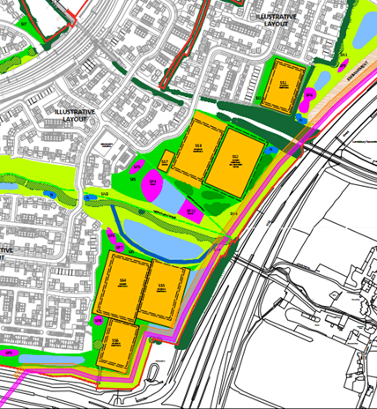
Fig. 1. Original Design

Fig. 2. Revised Design

Contact information
Donna Whinham
Strategic Major Sites Team Manager
01454 865204
www.southglos.gov.uk

